Experiment: 5 Date:

Steepest-Ascent Hill Climbing Algorithm

AIM: Program for implement a variation of the Hill Climbing problem.

Theory:

Steepest-Ascent Hill Climbing is a local search algorithm used in Artificial Intelligence to find an optimal solution by continuously moving from the current state to the best neighbouring state.
It is an improved version of Simple Hill Climbing. In Simple Hill Climbing, the algorithm moves to the first better neighbour it encounters. In Steepest-Ascent Hill Climbing, the algorithm evaluates all possible neighbouring states and moves to the neighbour with the highest evaluation value.
The process continues until none of the neighbouring states is better than the current state.
For a maximization problem, the algorithm moves toward a state with a higher evaluation value. Therefore, it is called Steepest-Ascent because it attempts to make the largest possible upward move at every step.

Characteristics of Steepest-Ascent Hill Climbing
- It is a local search technique.
- It evaluates all neigh boring states before making a move.
- It selects the best neighbouring state.
- It generally makes a better choice than Simple Hill Climbing at each step.
- It requires less memory compared to many systematic search algorithms.
- It can still get stuck at a local maximum.
- It may get stuck on a plateau.
- The final solution can depend on the initial state.
- It does not guarantee finding the global optimum.

Difference Between Simple and Steepest-Ascent Hill Climbing

Simple Hill Climbing | Steepest Ascent Hill Climbing
Examines neighbours one at a time. | Examines all neighbours.
Moves to the first better neighbour found. | Moves to the best neighbour.
May not select the best available move. | Selects the best available move
Usually requires less computation per step. | Requires more computation per step
Can get stuck at a local maximum | Can also get stuck at a local maximum

ALGORITHM:

- Start with an initial state.
- Evaluate the current state.
- Generate all neighbouring states.
- Evaluate all the neighbouring states.
- Select the neighbour with the highest evaluation value.
- If the selected neighbour is better than the current state, move to that neighbour.
- Otherwise, stop the search.
- Return the current state as the solution.
Example:
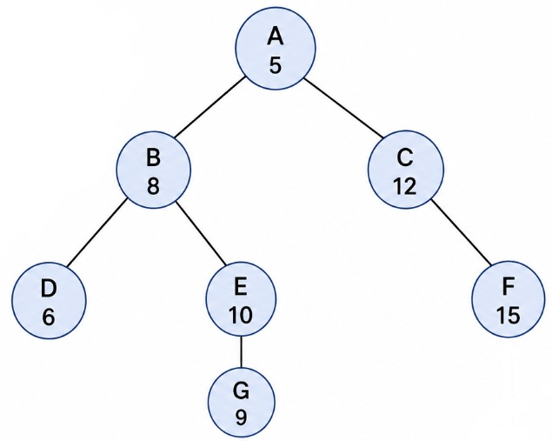

Consider the following graph. The numbers inside the nodes represent the heuristic/evaluation value of each state. Since this is a maximization problem, higher value represents a better state. higher value represents a better state.
Suppose the algorithm starts at A(5).

Step | Current State | Neighbours Examined | Best Neighbour | Action
1 | A(5) | B(8), C(12) | C(12) | Move to C12)
2 | C(12) | F(15) | F(15) | Move to F(15)
3 | F(15) | - | - | No neighbour, Stop

At A(5), the neighbouring states are:
- B(8), C(12)

Steepest-Ascent Hill Climbing evaluates both neighbours and selects C(12) because it has the highest value.
Next, at C(12), the neighbour is:
- F(15)

Since F(15) is better than C(12), the algorithm moves to F(15).

At F(15), there is no neighbouring state with a higher value. Therefore, the algorithm stops.

CODE:

OUTPUT:

CONCLUSION:

